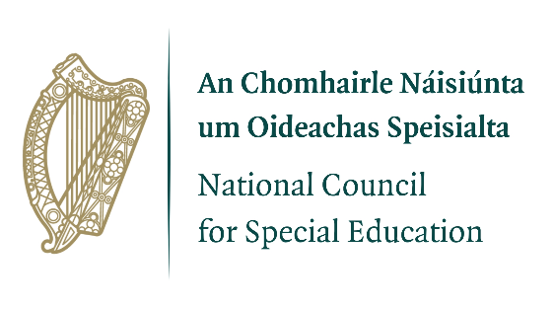

NCSE Formal Complaints Form
This form is for formal complaints. This form should not be used if your complaint relates to an allocation of Special Education Teaching support Special Needs Assistant support to a school – please use the relevant review processes instead.)
Your contact information:
Name
Address
Telephone/mobile number
Email
Date
Brief description of what happened
When (dates/times)
Parties involved (Including NCSE personnel)
Concerns, or the issues that form your complaint – (related to the NCSE standard of service or the NCSE staff code of professional practice?)
Anything you/other parties have done to resolve or follow-up on the issue before sharing this formal complaint
What actions are sought
Has the complaint been raised at point of service delivery? |  | Yes |  | No
If yes, what was the outcome?
If not raised at point of service delivery, please advise your reasons for not doing so.
Please attach copies of any relevant documents or correspondence.

Please send your completed form and any relevant documents or correspondence to:

NCSE Customer Feedback & Complaints
National Council for Special Education
1-2 Mill Street, Trim
Co. Meath,
C15 P2KC

E-mail: Feedback@ncse.ie

NCSE SET and SNA review information: SET Review – https://ncse.ie/application-for-set-review Exceptional Review of SNA allocation - https://ncse.ie/application-for-sna-exceptional-review

